HH
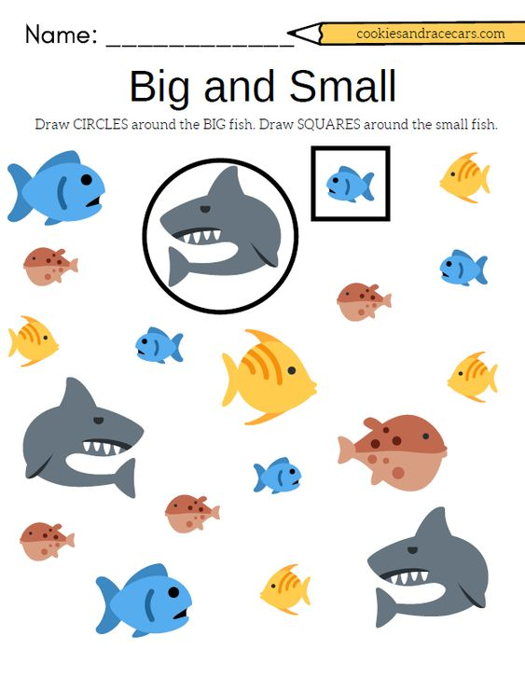

1.GO ZIKLO
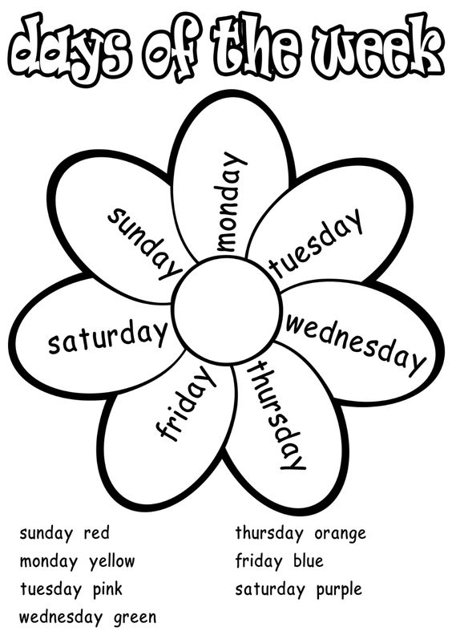

2-3.ZIKLOAK BLACK OR WHITE MICHAEL JACKSON

I took my baby on a Saturday bang
Boy is that girl with you
Yes we're one and the same
Now I believe in miracles
And a miracle has happened tonight
But if you're thinking about my …………
It don't matter if you're black or white
They print my message in the Saturday Sun
I had tell them I ain't second to none
And I told about equality
And it's true either you're wrong
Or you're right
But if you're thinking about my baby
It don't matter if you're …………or white
I am tired of this devil
I am tired of this stuff
I am tired of this business
Sew when the going gets rough
I ain't scared of your …………
I ain't scared of no sheets
I ain't scared of nobody
Girl when the going gets mean
Protection
For gangs, clubs, and nations
Causing grief in human relations
It's a turf war
On a global scale
I'd rather hear both sides of the tale
See, it's not about races
Just places, …………
Where your blood comes from
Is where your space is
I've seen the bright get duller
I'm not going to spend
My life being a color
Don't tell me you agree with me
When I saw you kicking dirt in my eye
But you're thinking about my baby
It don't matter if you're black or white
I said if you're thinking about my baby
It don't matter if you're black or white
I said if you're thinkin' of being my brother
It don't matter if you're black or white
It's black, it's white
It's tough to you to be, yeah
It's black, it's white
It's black, it's white
It's tough to you to be, yeah
It's black, it's white

WORDS: faces, brother, black, baby

