HH
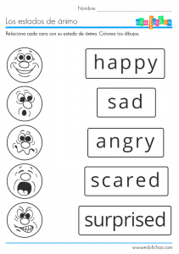

1.GO ZIKLO
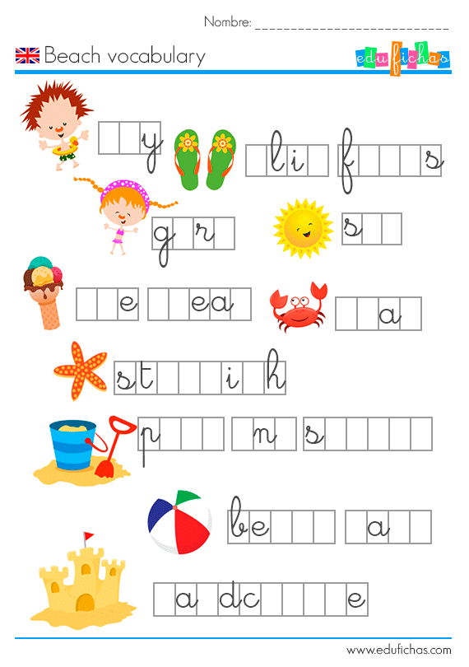

2-3 ZIKLOAK
PERFECT

I found a love for me
Darling, just dive right in
And follow my lead
Well, I found a girl, ………… and sweet
I never knew you were the someone waiting for me
'Cause we were just kids when we fell in love
Not knowing what it was
I will not give you up this time
Darling, just ………… me slow, your heart is all I own
And in your eyes, you're holding mine
Baby, I'm dancing in the dark with you between my arms
Barefoot on the …………, we're listenin' to our favorite song
When you said you looked a mess, I whispered underneath my breath
But you heard it, darling, you look ………… tonight
Well, I found a woman, stronger than anyone I know
She shares my dreams, I ………… that someday I'll share her home
I found a love, to carry more than just my secrets
To carry love,…

WORDS
Perfect hope grass kiss beautiful

https://www.youtube.com/watch?v=UDDMYw_IZnE

