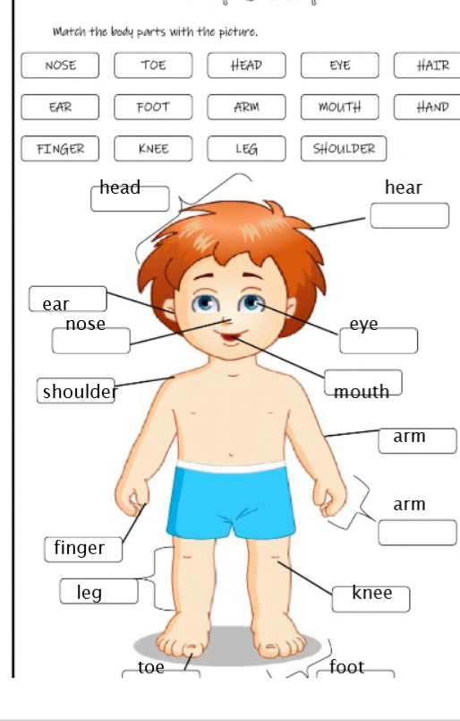
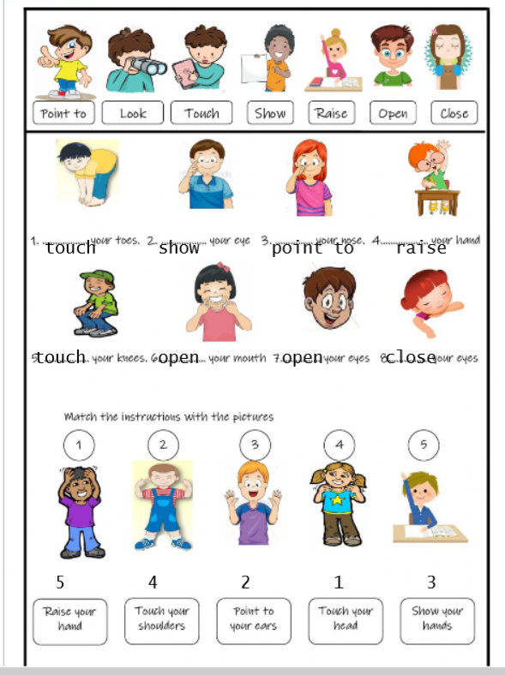

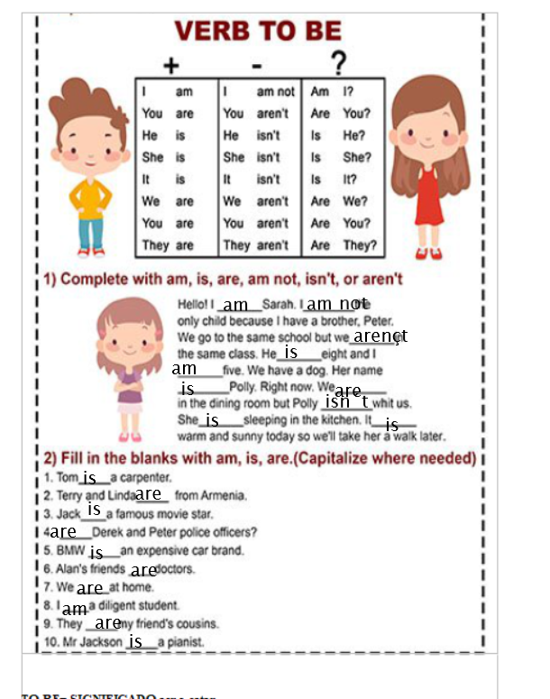

Werb to be = ser o estar.
I am at hone = yo estoy en casa. 2. He is a teacher= el es profesor.

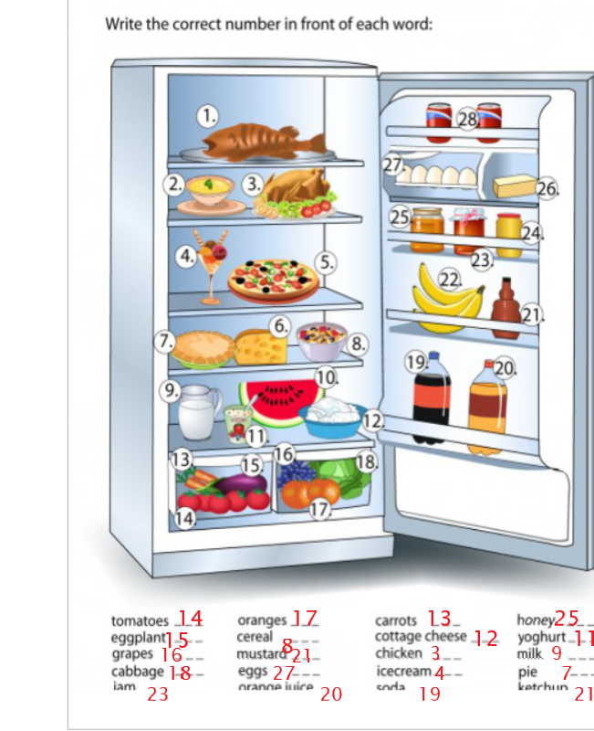

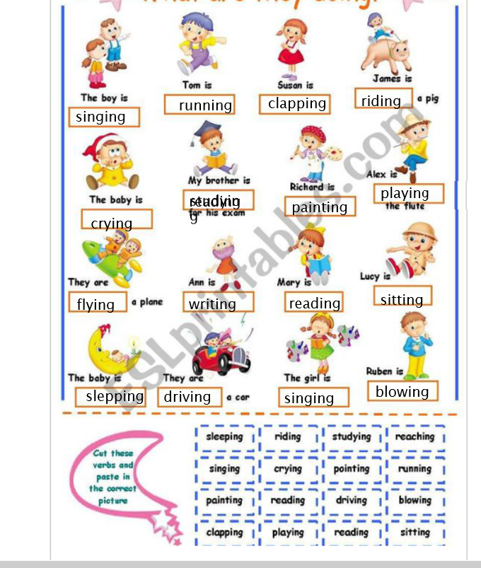

Riding = montando .He is riding a horse.
Writing = escribiendo i am writing
Blowing = soplando She is blowing the balloon.
Reaching= alcanzando i am reaching my feet.

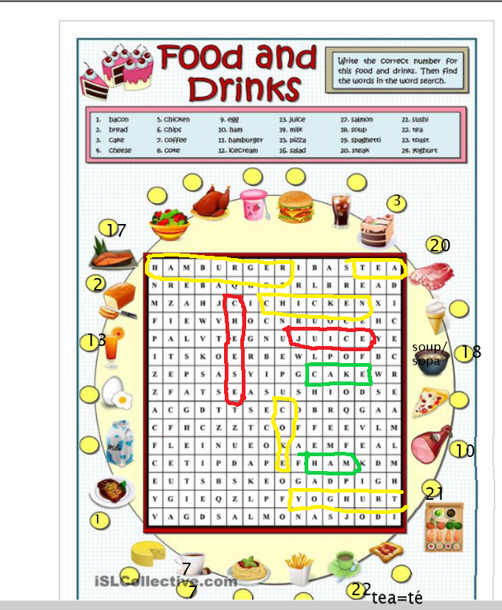

Now finish the exercise/ bukatu ariketa/ terminar el ejercicio.

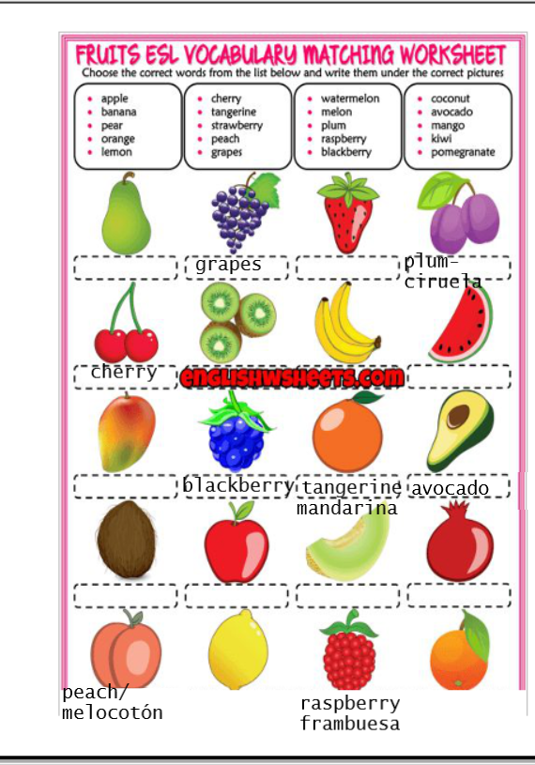
Finish the exercise./ BUKATU.
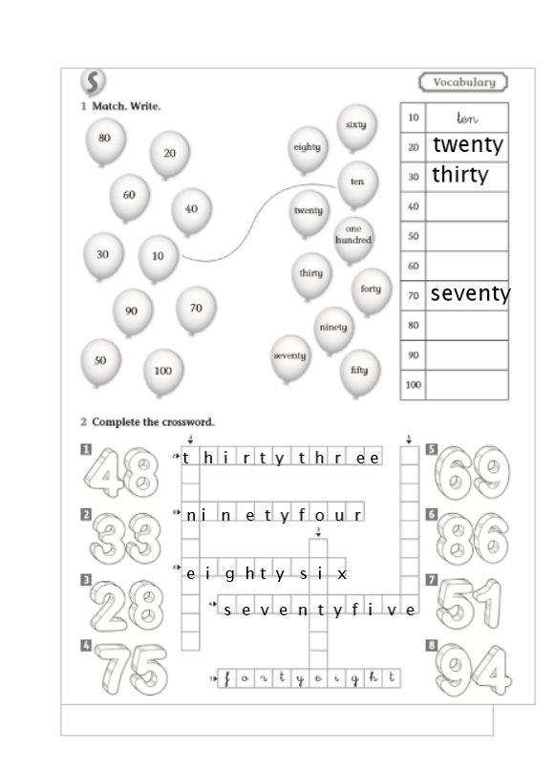
1= one 4= four 7= seven 10= ten
2= two 5= five 8= eight
3= three 6= six 9= nine

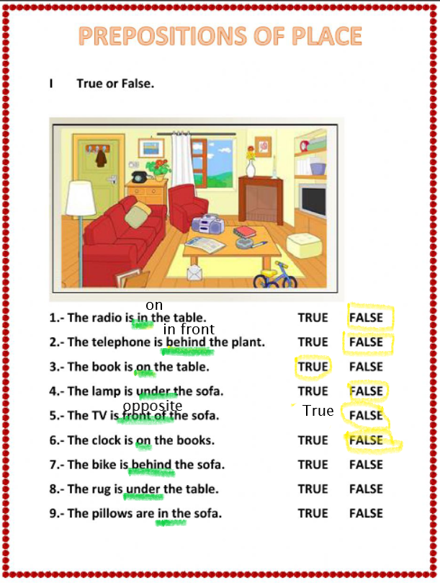
On= encima in= dentro
Under= debajo in front of= delante de ( en la fila..)
Behind= detrás opposite= en frente de, al otro lado de.

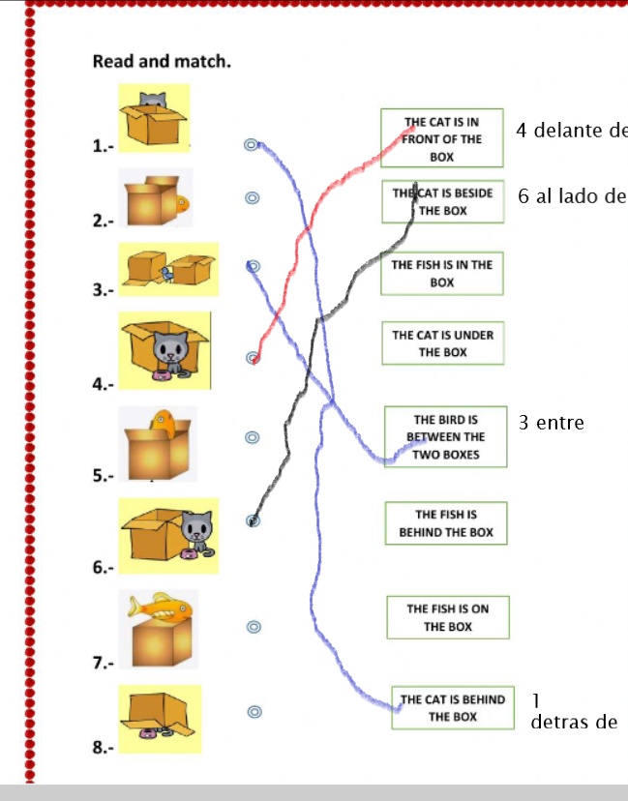

Beside/ next to = al lado de.
Between= entre.

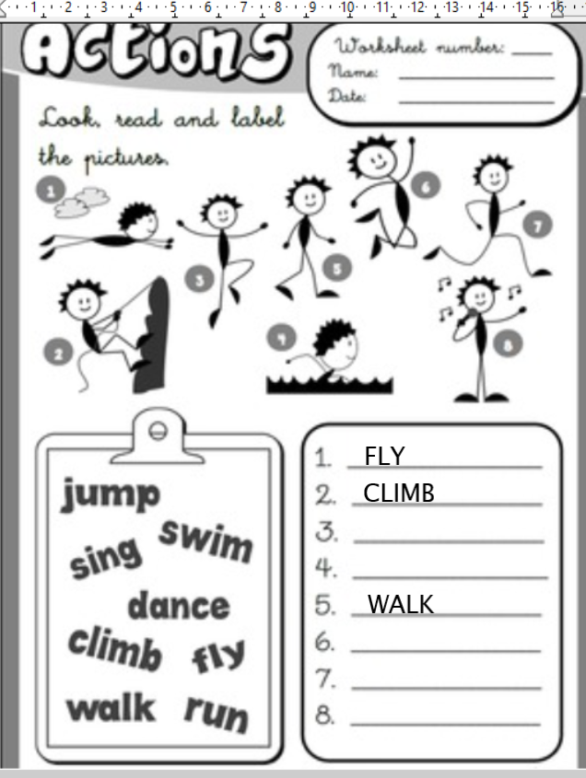
FINISH THE EXERCISE.

